|  |  |
| --- | --- |
| Course Name | ITD 2313 – Script Programming |
| Instructor | Put instruction name here |
| Student Name | Put student name here |
| Due date | Put assignment due date here |
| Grade | Put grade earned here |
| Grading Comments | Put instructor comments here |

### Page 103

1. The first code example block which is about 1/2 way down the page is a simple review of some previous material dealing with strings.
2. The 2nd code example block on the page near the bottom starts looking into what we can do with strings.

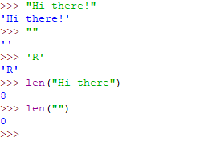

### Page 105

1. Slicing is an important concept when using strings in Python.  Be sure to do all of the code example block in the middle of the page.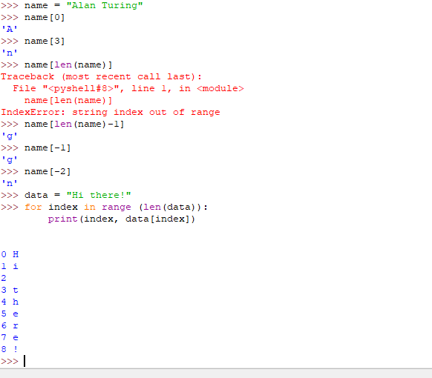

### Page 106

1. There is a small code block example at the top of the page to demonstrate how the operator works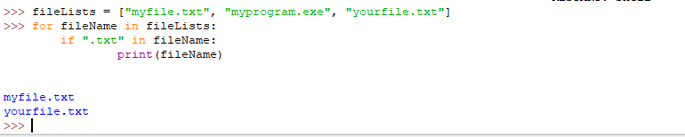

### Page 108

1. There are two rather large code example blocks here.  One to Encode and one to Decode.  The good news is that you do not have to type them in.  They are included in the data files for this chapter.  Run the programs multiple times using 3 at least one set of code and decode to show the versatility of the two programs.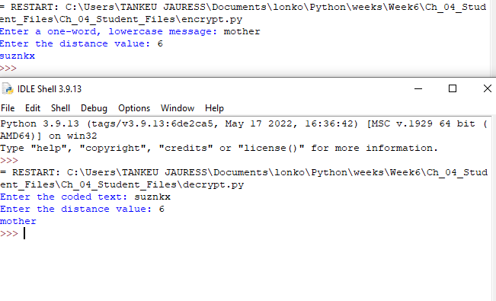

### Page 111

1. The code example block for this one is also available in your download for this chapter.  Run it and show the same inputs as the text and then run them again with different inputs to see what you get.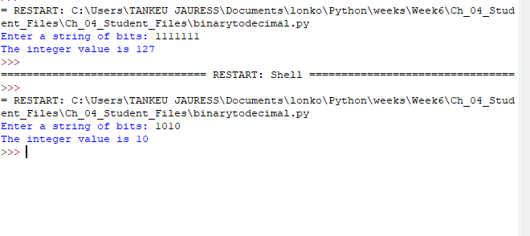

### Page 112

1. The code example block for this one is also available in your download for this chapter.  Run it and show the same inputs as the text and then run them again with different inputs to see what you get.

### Page 115

1. 3/4 the way down the page you will find the code example block for this page

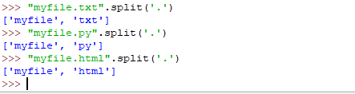.

### Page 117

1. The first code example block on this page is rather long so it might take multiple screen shots to get this one and the next one on the page.
2. The second code example block on the page is at the bottom.  It does not roll over so it is included on this page.  Again it might take multiple screen shots to get all the code example blocks on this page.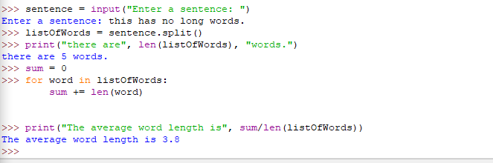

### Page 119

1. This is an unusual one.  In this small section, there are several code lines but there is no output.  That is because the output is in a file.  So for this one, you will run the code lines start to finish and then grab the screen shot of all of them.  Then to show they worked, find the file it created on your hard drive and open it.  Then grab a screen shot of that file open in whatever text editor you use.
2. Do not delete the file when you are done, you will use it later.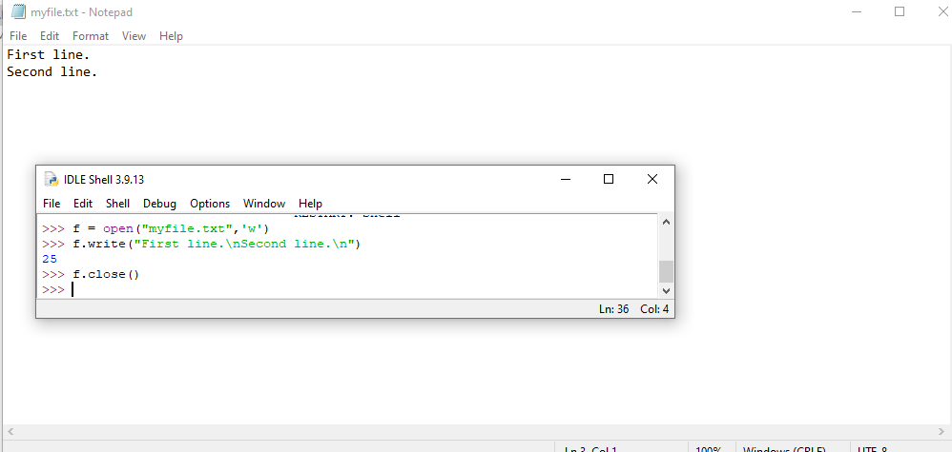

### Page 120

1. Normally for a single page we would do all the code blocks together but the file handling is a bit special.  It uses a file you created earlier so make sure the file name is correct.  Nothing may show when you execute the first code example block in this subsection of the text.  Still screen shot that you did it.
2. Executing the code example block just after the half way mark on the page will have output you can capture with your screen shot.
3. There will be output for the last code example block on this page to grab into the screen shot.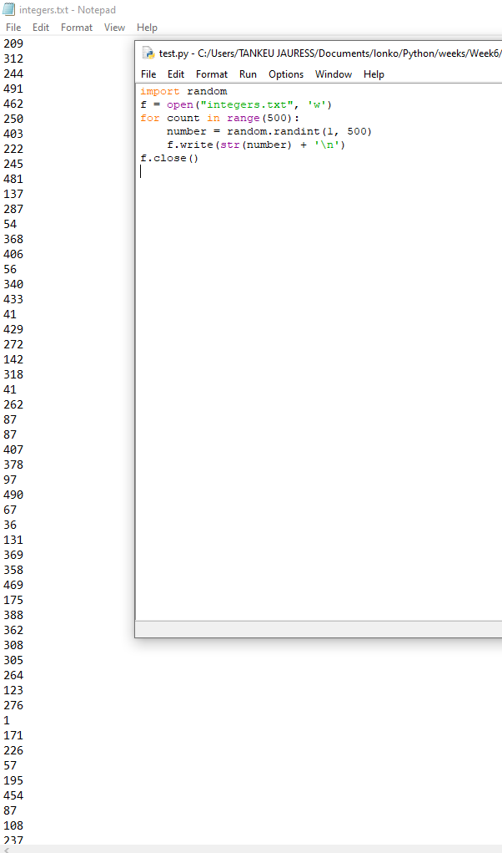

### Page 121

1. This code block will be towards the bottom of your page.  It utilizes one of the files created earlier.  Make sure you have the correct file name.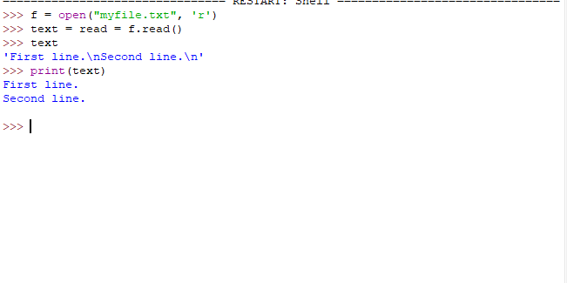

### Page 122

1. The code example block here uses that file again.  Check that file name to be sure.  There is output to capture for the screen shot.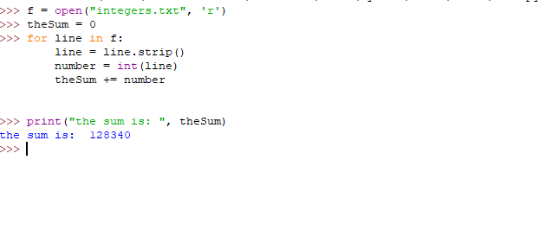

### Page 124

1. This page does have a code example block you are to execute and run and grab that screen shot for the submission document.